Two parts

1. Construction of voltage dividers
   1. Measure the resistance of two resistors of two different resistance values
      1. Quantify the effect of technition body resistance
      2. Quantify the effect of lead resistance
   2. Construct a voltage divider and measure the voltage at the output.
      1. Quantify the case of infinit multimter resistance
      2. Quantify the effect of 10 Mohm multimeter resistance
2. Design and execute expirermenet involving mobile humidity sensor
   1. Where is humidity measurement important
   2. How are humidity sensors calibrated
   3. How do saturated salt solutions work
3. Describe the general procedure for hooking up transducers

Key words to use

* Volt
* Ohm
* mA
* Input Impedance
* Loading Error
* Humidity
* Relative Humidity
* Voltage Divider
* Thermistor
* Temperature Compensation
* Case Ground

**Introduction**

Voltage and resistance are ubiquitous transducer outputs in engineering measurement. Therefore, the accuracy, resolution, and precision of a measurement can be limited by the ability to measure these quantities. While any basic multimeter has modes for both voltage and resistance measurement, a number of factors can work to bias the reading. When measuring large resistances, clumsy handling of the test leads can introduce the technicians body resistance in parallel with the circuit. Any real multimeter with non-infinite input impedance will produce a similar effect. These types of errors are called loading errors and act as resistances in parallel to the measured resistance. When measuring very small resistances, the resistance of the test leads themselves can overwhelm the smaller resistance being measured and appears as resistances in series with the measured resistance.

Inside of most multimeters, resistance measurement is actually performed using voltage measurement. A precise, known current is pushed across the device under test, and the resistance of the device can be calculated based on the voltage drop according to ohms law.

$$V=IR$$

In precision resistance measurement four measurement leads are used. Two are used to push the current across the device under test, and two are used to measure the voltage drop across the device. This eliminates any voltage drop due to resistance in the test leads because no current flows through them.

Humidity measurement is an example of a transducer that produces a voltage output. Maintenance and monitoring of relative humidity is critical in applications such as medical air lines, clean rooms, dryers, general HVAC. Humidity is usually reported as relative humidity, which ratio of the current vapor pressure to the saturation vapor pressure. This quantity is dependent on temperature because as temperature increases the saturation vapor pressure rises.

$$\%RH=\frac{P_{w}}{P_{s}}×100\%$$

Where,

$P_{w}$ is the vapor pressure of water

$P_{s}$ is the saturation vapor pressure

The HIH-4602-A/C is a precision, solid state humidity sensor with a reported accuracy of ±3.5 %RH. The sensor produces a ratiometric output that is linearly proportional to the voltage input and the relative humidity. Because the output is ratiometric, the sensor requires a stable, known voltage input to produce a reliable measurement.

A stable, portable, 4.5 V voltage input can be generated using a balanced resistor divider and 9 V battery. Given the unknown state of charge of the battery, it is best to measure the voltage output of both the battery and the voltage divider directly once they are assembled in the circuit.

Precision humidity sensors can be calibrated using a series of saturated salt solutions. Saturated salt solutions produce a vapor with a relative humidity that is dependent on the salt used, and only weakly dependent on the temperature of the setup. Tables of known relative humidity for common salts are available from standards agencies such as the National Institute of Standards and Technology (NIST), the National Bureau of Standards (NBS) or instrument suppliers such as OMEGA.

The effect relies on the way water vapor reaches equilibrium with a solution. Water vapor evaporates from solution at a known rate dependent on temperature, and also re-enters the solution at a known rate dependent on temperature. Adding a salt interferes with the first rate in a way that depends on the size of the hydration shell of the dissolved ions without having any effect on the second rate. In this way, saturated salt solutions can generate standardized relative humidities in a repeatable way.

**Materials and Methods**

The resistance of two, 1kohm resistors and two, 1 Mohm resistors was measured using a multimeter in resistance mode (MASTECH). In order to test the effects of the test technitians body resistance when holding on to the multimeter leads, the resistance of the technitian was measured directly. Further, in order to measure the lead resistance, the leads were shorted together, and a measurement was taken.

A voltage divider circuit was constructed first using 1 kOhm resistors, and then again using 1 MOhm resistors. The voltage output was again measured using the voltage setting of a multimeter (MASTECH) and the voltage divider was supplied by a 9 V battery. The open circuit voltage of the battery was later measured by the same multimeter.

$$V_{o}=\left(\frac{R_{2}}{R_{1}+R_{2}}\right)V_{i}$$

A mobile humidity sensor rig was constructed by powering a Honeywell HIH-04602 relative humidity sensor with the 1kohm version of the voltage divider constructed above. The output of the sensor was read using a multimeter in voltage mode. The transfer function in listed in the datasheet was used to convert output voltage to relative humidity. Further, the temperature compensation was applied assuming the sensor had reached the same temperature as the water bath.

$$\%RH=\frac{\left(\frac{V_{o}}{V_{s}}-0.16\right)}{0.0062}$$

$$True \%RH=\frac{Sensor \%RH}{1.0546-0.0016⋅T}$$

The humidity sensor was calibrated using a series of saturated salt solutions (KCl, NaCl, and MgSO4). A 50 mL Erlenmyer flask was charged with 50 g of the selected salt, and then filled to the 40 mL mark with boiling hot distilled water. The solutions did not dissolve all of the salt in the flask and remainined statured. The flask was placed in a water bath to control the temperature. The temperature was varied before reading the relative humidity in the flask. The humidity sensor was allowed to settle for at least a minute before each measurement.

**Results and Discussion**

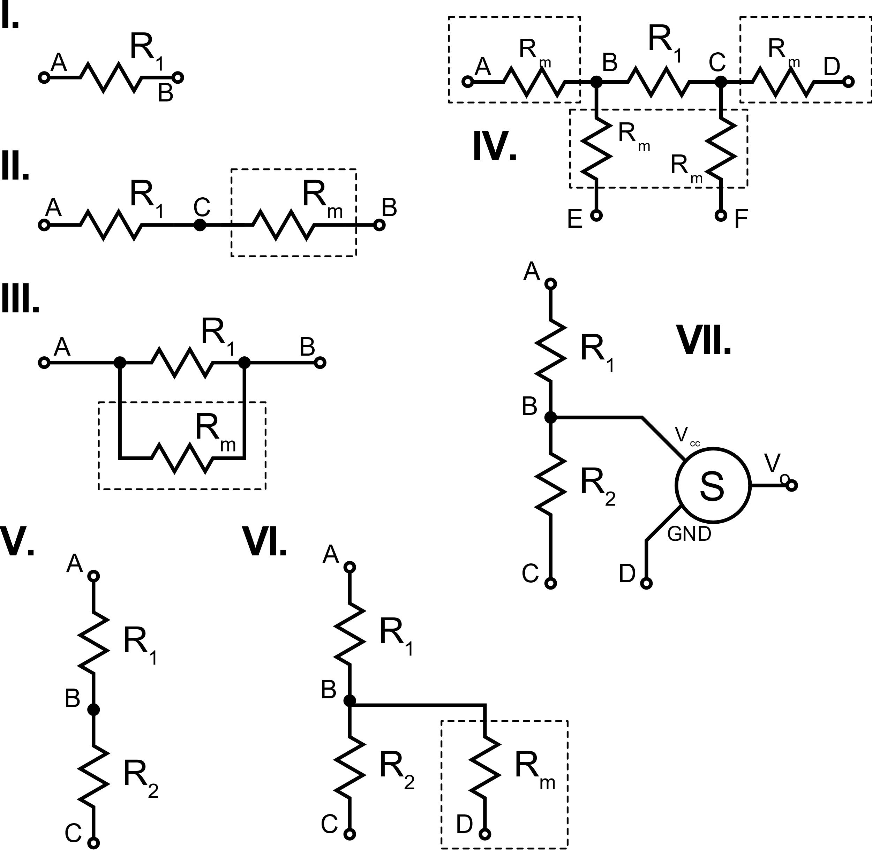

Types of analysis

1. Single resistor measurement
2. Single resistor with parallel error
3. Single resistor with series error
4. Four wire measurement
5. Normal voltage divider
6. Voltage divider with loading error (multimeter impedance)
7. Sensor setup

Suggestions

1. Draw the circuit diagram and analysis for the resistance measurements and voltage divider
2. Explain how you constructed your mobile humidity sensor. Include a circuit diagram.
3. Present the results of your experiment.

**References**

https://www.omega.com/temperature/z/pdf/z103.pdf